EMS – HR

The Employee Management System (EMS) is an AI-powered HR platform designed to streamline employee administration, security, and engagement by providing modules such as Login & Authentication with secure email-password access, password reset, and restricted admin access; a Dashboard that gives a live snapshot of presence (WFH, WFO, online/offline users) along with holiday and birthday reminders and quick sidebar navigation to other modules; Attendance & Calendar Management with event scheduling, company calendar for working days, weekends, and holidays, and AI insights for anomalies and absenteeism risks; Org Chart for managing hierarchy with add, edit, delete, and zoom options; Shift Assignment to allocate working hours, extra time, and track current assignments; Geo-Fencing & Work Location to configure GPS-based office zones and WFH permissions; Payroll Management with salary structure (Basic 70%, HRA 20%, Special Allowance 10%), deductions (PF, Professional Tax), salary configuration, bank details, payslip generation, and status tracking; Employee Management for adding, editing, or deleting employee records; Leave Management with AI-powered approval insights, conflict detection, policy reminders, and full leave history; Chat & Meeting Room for global, private, and group communication with AI chatbot support; Office IP & Device Monitoring to restrict access via whitelisted IPs, track login logs, detect anomalies, and flag suspicious logins; Issue Management to track employee complaints and bug reports with status updates; Voting & Polls for anonymous employee participation in decision-making; AI Analytics providing salary optimization, attendance analysis, performance prediction, workload balancing, engagement analysis, and smart scheduling; and Settings for appearance customization (light/dark mode) and security controls (roles, permissions). Overall, the system enhances HR efficiency with centralized employee data, payroll automation, secure access controls, AI-driven insights, and collaboration tools, ensuring optimized workforce management, improved engagement, and robust organizational security.

**Navigation Panel (Sidebar)**

The sidebar provides quick access to various modules:

* **Dashboard** – Overview of system activities.
* **Org Chart** – Organizational hierarchy.
* **Work Location** – Assign & manage geo-fence and work-from-home.
* **Shift Assign** – Allocate employee shifts.
* **Payroll** – Salary and payment management.
* **Attendance** – Track employee attendance and work hours.
* **Manage Employees** – Add, update, or remove employees.
* **Leave Approvals** – Manage employee leave requests.
* **Chat & Meeting Room** – Internal communication.
* **Office IPs** – Office access management.
* **Check Device** – Validate login devices.
* **Chatbot** – AI-powered assistant for queries.
* **Complaints** – Employee complaint management.
* **Voting – Cast votes and make collective decisions.**
* **AI Analytics – Gain insights using artificial intelligence.**
* **Settings – Customize and manage application preferences.**

1. **Login & Authentication**

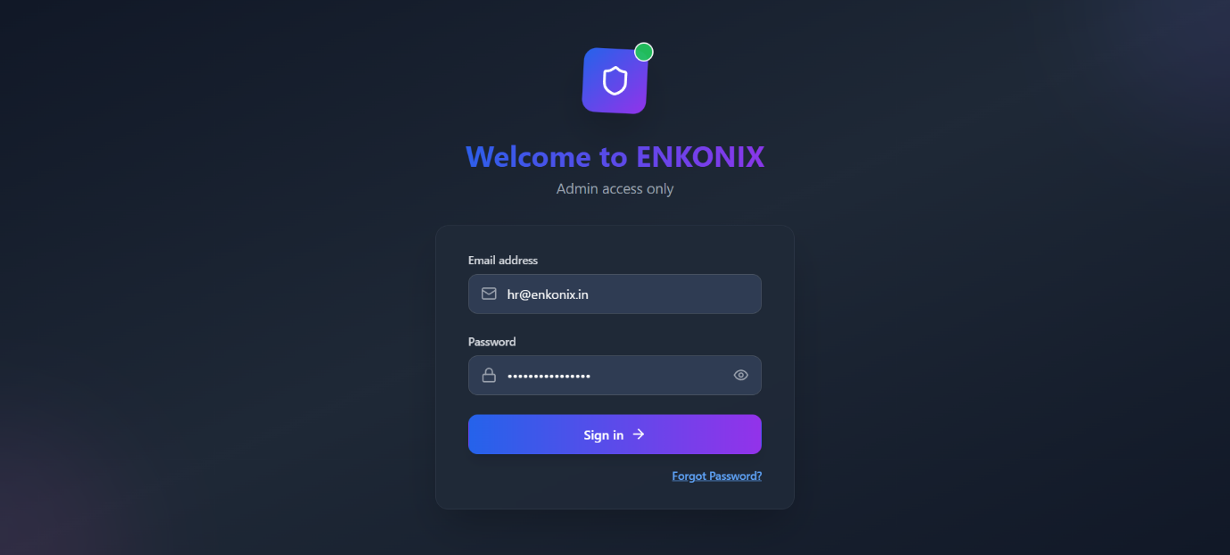

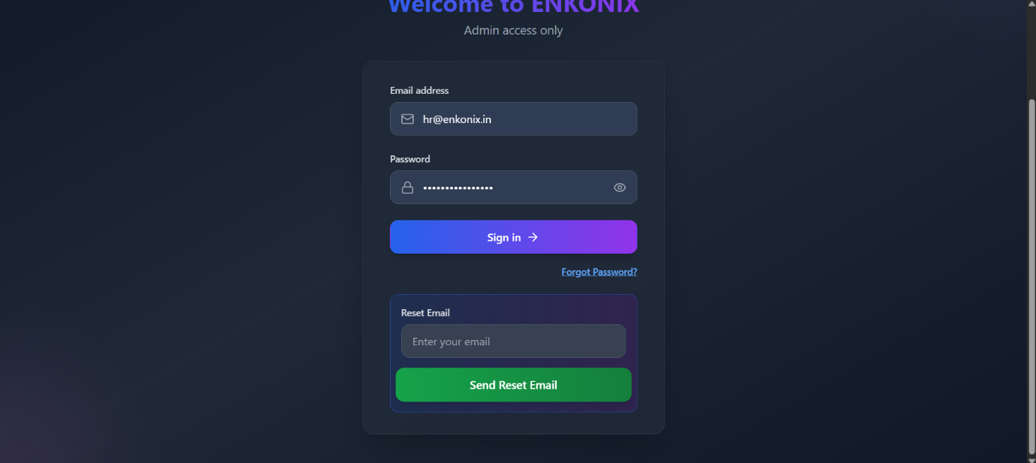

**Purpose**

* To provide **secure access** for admins/employees.
* Prevents unauthorized entry into the system.

**Features**

* **Email & Password fields** → Standard login.
* **Password visibility toggle** → Users can check what they typed.
* **Forgot Password link** → Redirects to password reset flow.
* **Reset Email box (variant)** → Lets users directly request a reset link without leaving the page.
* **Restricted Access Warning** → Clearly states “Admin Access Only.”

**Typical Flow**

1. User enters email & password.
2. Clicks **Sign in**.
3. If password forgotten → click **Forgot Password?** or enter email in **Reset Email** box → system sends reset link.

**Main Dashboard**

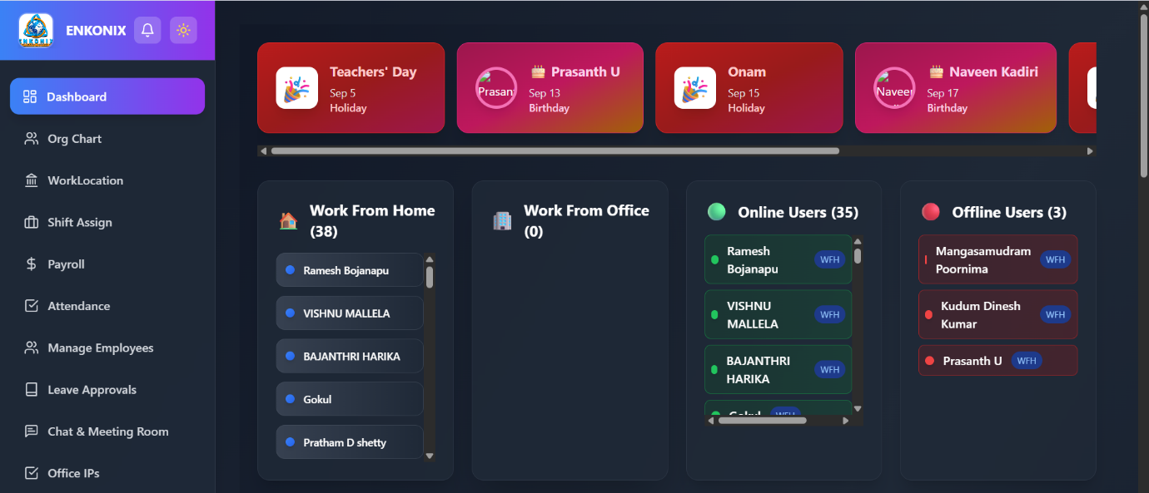

**Purpose**

* To give a **live snapshot** of employees’ presence and upcoming events.

**Components**

1. **Holiday & Birthday Carousel**
   * Scrollable cards showing company holidays and employee birthdays.
   * Example: *Teachers’ Day, Onam, Employee birthdays*.
   * Helps HR/managers remember special dates.
2. **Work From Home (WFH) Panel**
   * Count + list of employees working remotely.
   * Employee details shown with name and status chip.
3. **Work From Office (WFO) Panel**
   * List of employees currently working from the office.
4. **Online Users Panel**
   * Real-time presence status.
   * Green dot = Online.
   * “WFH” chip → user is remote but available.
5. **Offline Users Panel**
   * Employees who are not logged in.
   * Red dot = Offline.

**Typical Flow**

* HR/Admin opens dashboard →
* Checks **WFH/WFO balance** →
* Sees **who’s online/offline** →
* Uses sidebar to navigate to detailed modules.

**Attendance Dashboard (Calendar View)**

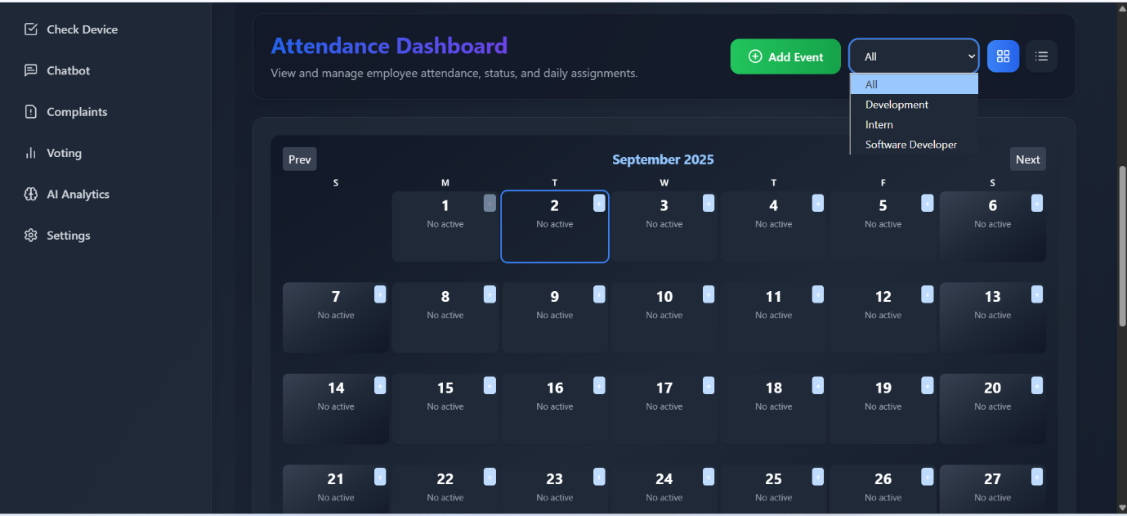

**Purpose**

* To track, filter, and manage events/tasks for employees.

**Features**

* **Month view calendar**.
* **Add Event button** → Create a new event.
* **Day-level + icon** → Quick add for specific dates.
* **Team/Role filter** → Show events only for selected groups (e.g., Development, Interns).
* **Prev/Next navigation** → Move between months.
* **Empty day marker** → “No active” shows no events/tasks for that day.

**Typical Flow**

1. Select **Team/Role filter**.
2. Navigate to month/day.
3. Click **Add Event** or **+ icon**.
4. Create event → appears on calendar.

**Add New Event (Modal Window)**

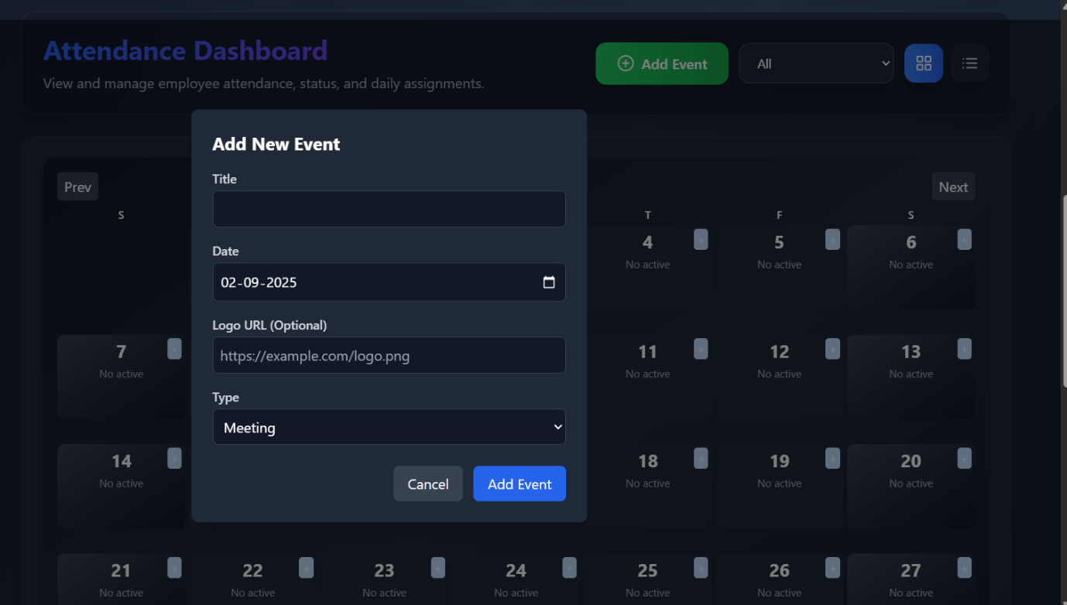

**Purpose**

* To create and save events like meetings, holidays, or team activities.

**Fields**

1. **Title** → Short name (e.g., “Sprint Planning”).
2. **Date** → Pick from calendar.
3. **Logo URL (Optional)** → Attach an image (team logo, event icon).
4. **Type** → Choose from dropdown (Meeting, Holiday, Training, etc.).

**Actions**

* **Add Event** → Saves to system & shows on calendar.
* **Cancel** → Closes modal without saving.

**Company Calendar (Month/Year with Status Badges)**

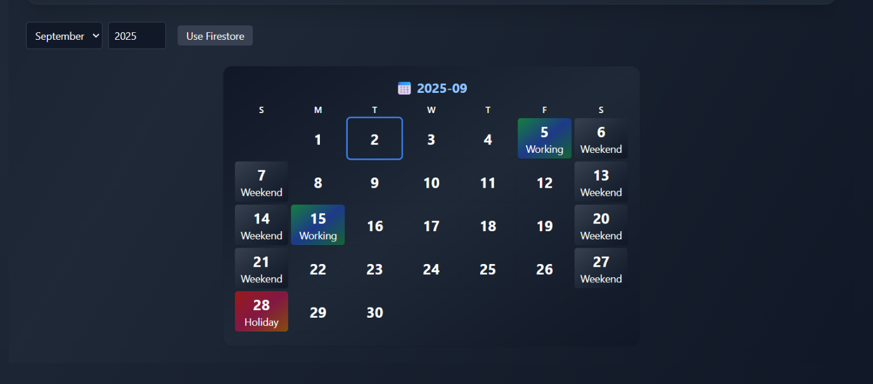

**Purpose**

* To define working/non-working days for the organization.
* Ensures **payroll, attendance, and shift planning** follow correct rules.

**Features**

* **Month & Year selectors** → Navigate to any period.
* **Use Firestore button** → Switches calendar to fetch data from Firestore database.
* **Status Badges**:
  + 🟢 Working → Regular working day.
  + ⚫ Weekend → Weekly off.
  + 🔴 Holiday → Company-declared holiday.
* **Selected Date Highlight** → Blue outline around clicked day.

**Typical Flow**

1. HR/Admin selects a **month & year**.
2. Clicks a **date** → assigns/edits its status (Working/Weekend/Holiday).
3. Calendar updates → all dependent modules (attendance, payroll) reflect changes.

**Company Org Chart – Simple Documentation**

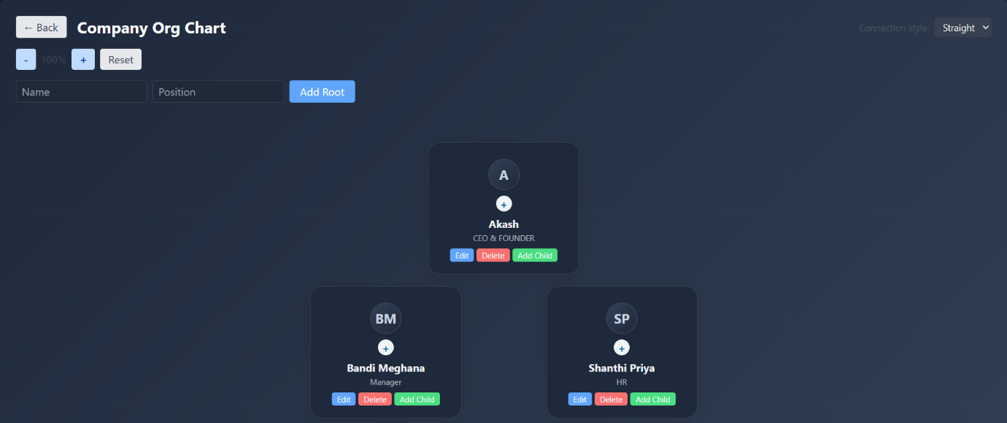

**Purpose**

* To show the company hierarchy (who reports to whom).
* Helps HR/Managers manage structure easily.

**Features**

* **Add Root** → Add the top-level person (e.g., CEO).
* **Add Child** → Add subordinates under any employee.
* **Edit** → Change employee name or position.
* **Delete** → Remove employee (and their team).
* **Zoom & Reset** → Adjust chart view.
* **Connection Style** → Choose line style (straight/curved).

**Assign Shift to Employee**

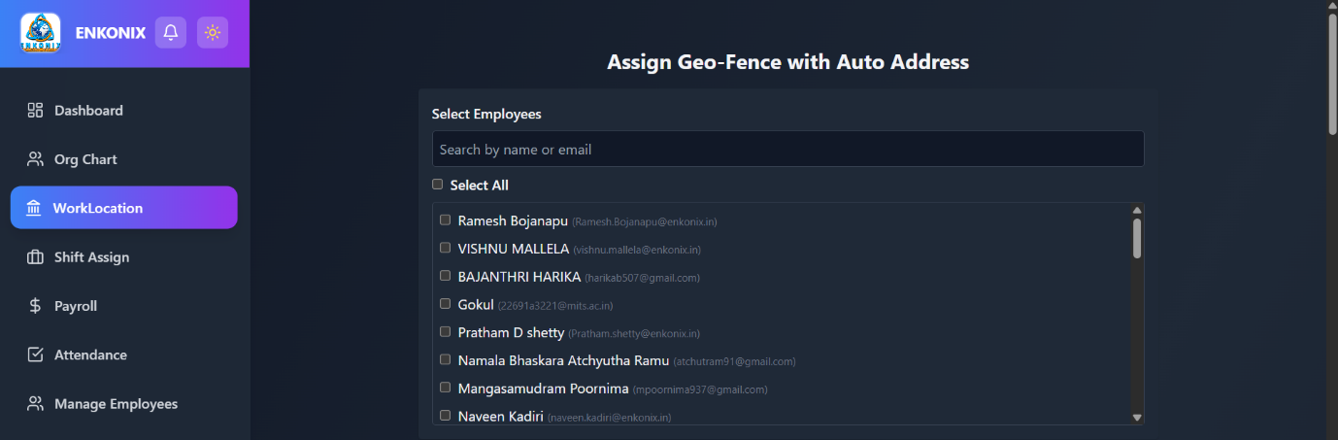

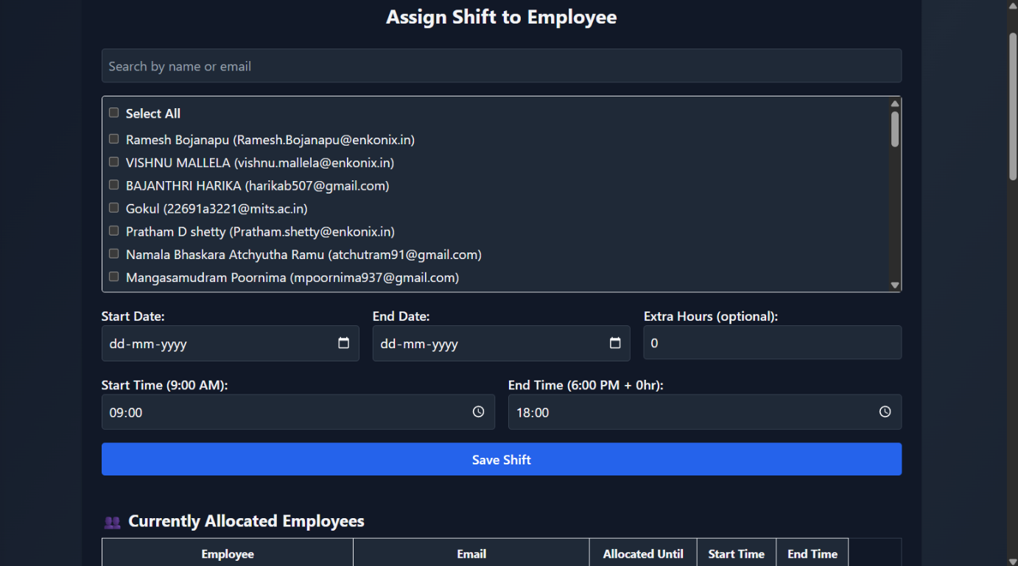

This module allows administrators or HR managers to assign shifts to one or more employees.

**Features:**

* **Employee Selection**
  + Search by employee name or email.
  + Select individual employees or use the **Select All** option.
* **Shift Assignment**
  + **Start Date / End Date**: Define the duration of the shift assignment.
  + **Extra Hours (optional)**: Add overtime hours to the employee’s shift.
  + **Start Time / End Time**: Specify working hours for the shift.
  + **Save Shift Button**: Saves the shift details and updates allocation records.
* **Currently Allocated Employees**
  + Displays a list of employees with:
    - Employee Name & Email
    - Allocated Until (end date of shift)
    - Start Time & End Time

**Geo-Fence & Work Location Assignment**

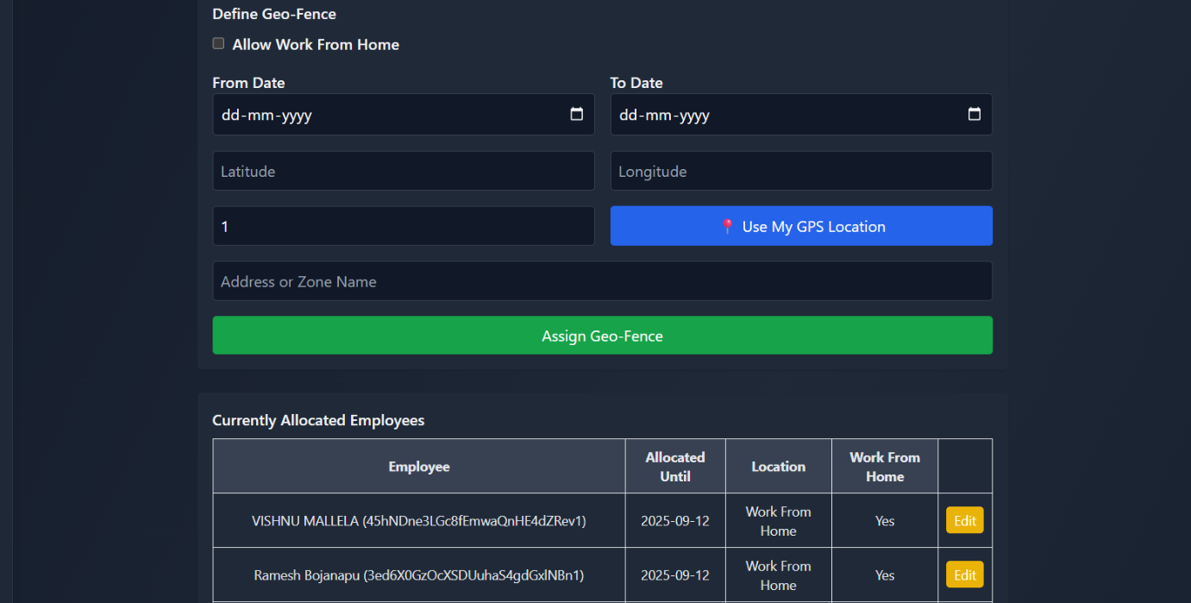

This module allows HR/admins to define physical work locations using GPS and configure **Work From Home** options.

**Features:**

* **Work From Home**
  + Option to allow employees to work remotely during a specified date range.
* **Geo-Fence Setup**
  + **From Date / To Date**: Validity period for the geo-fence.
  + **Latitude & Longitude**: Set coordinates of the work location.
  + **Use My GPS Location**: Auto-detect location using device GPS.
  + **Address or Zone Name**: Provide a custom zone name for easier identification.
  + **Assign Geo-Fence Button**: Apply and save geo-fence settings.
* **Currently Allocated Employees**
  + Shows employees with:
    - Employee details
    - Allocated Until date
    - Location
    - Work From Home status
    - **Edit option** for modifications

**Assign Geo-Fence with Auto Address**

This feature simplifies location assignment by automatically retrieving addresses from GPS coordinates.

**Features:**

* **Employee Selection**
  + Search and select employees (individually or all at once).
* **Auto Address**
  + System auto-fetches the address for selected coordinates, reducing manual entry.

**Enhanced Payroll Management Overview**

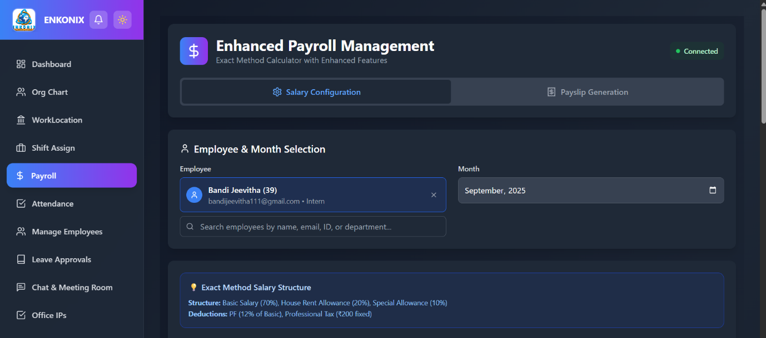

This module helps HR/admins configure salaries, manage employee payroll, and generate payslips using the **Exact Method Salary Structure**.

* **Salary Structure**
  + Basic Salary: 70%
  + House Rent Allowance (HRA): 20%
  + Special Allowance: 10%
* **Deductions**
  + PF: 12% of Basic
  + Professional Tax: ₹200 fixed

**Employee & Month Selection**

This section allows payroll to be processed for a specific employee and month.

* **Employee Selection**
  + Search by name, email, ID, or department.
  + Displays role and email for confirmation.
* **Month Selection**
  + Choose the payroll month.

**Salary Configuration**

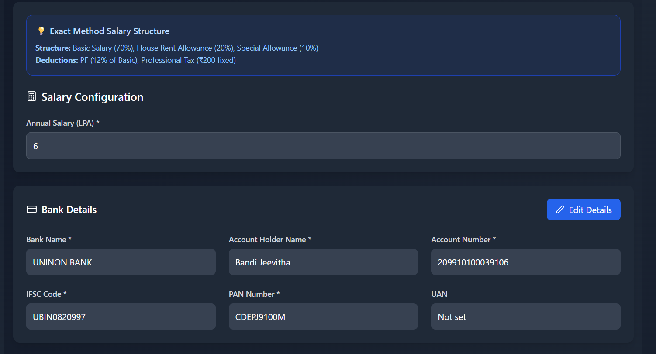

**Features:**

* **Annual Salary (LPA) Input**
  + Enter the employee’s annual salary in lakhs per annum.
* **Bank Details Section**
  + Bank Name
  + Account Holder Name
  + Account Number
  + IFSC Code
  + PAN Number
  + UAN (if applicable)
  + **Edit Details Button**: Update employee bank/payment details.

**Payslip Status Tracking**

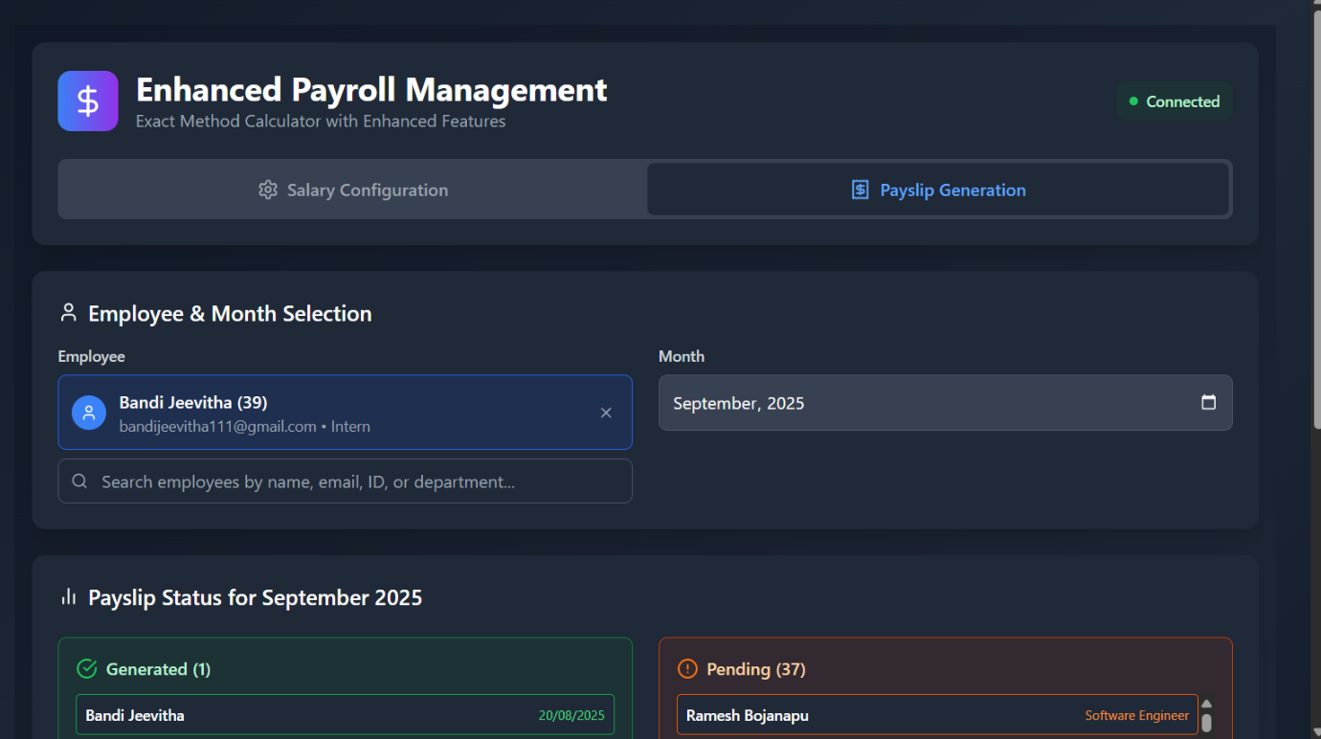

This feature shows payroll processing status for the selected month.

* **Generated**
  + List of employees whose payslips are already created (with generation date).
* **Pending**
  + Employees for whom payroll has not been generated yet.
* **Quick Actions**
  + Admin can directly open and process pending payslips.

**Payslip Generation**

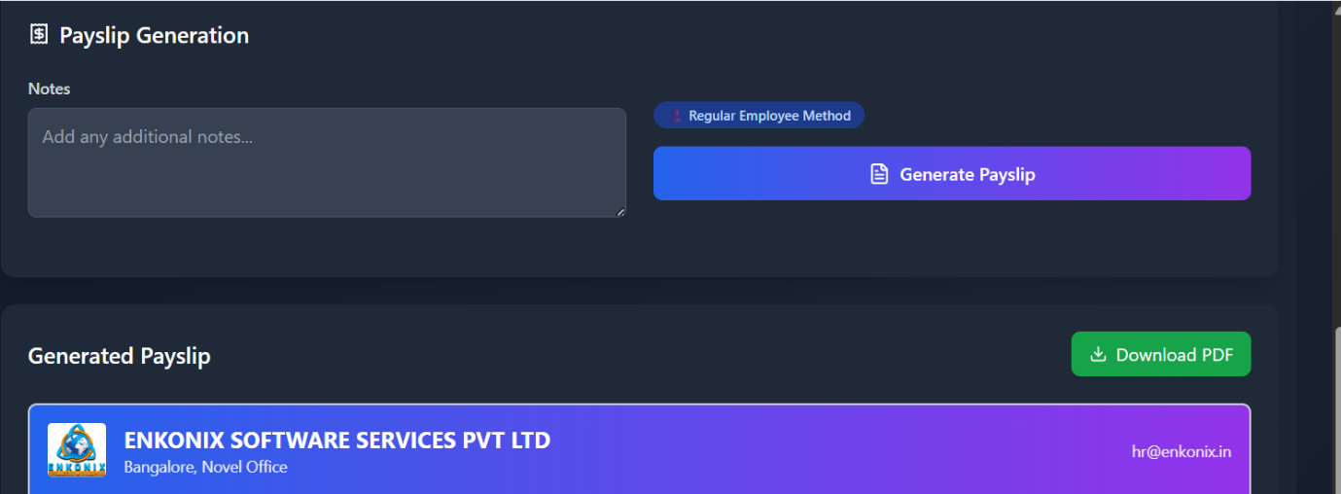

**Features:**

* **Notes Section**
  + HR/admin can add remarks or additional notes to the payslip.
* **Employee Method**
  + Select calculation method (e.g., Regular Employee Method).
* **Generate Payslip Button**
  + Creates the payslip based on the entered salary configuration and deductions.
* **Generated Payslip**
  + Displays employee’s payslip with company branding.
  + **Download PDF Option** available.

**Attendance Dashboard**

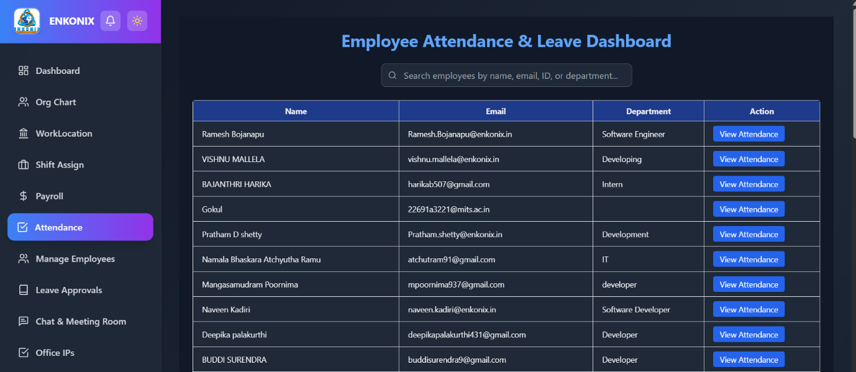

**Page Title:** *Employee Attendance & Leave Dashboard*

**Features:**

* **Search Bar** – Search employees by name, email, ID, or department.
* **Employee List Table:**
  + **Columns:**
    - Name
    - Email
    - Department
    - Action (View Attendance button)
* **Action Button – View Attendance**: Opens detailed attendance history for each employee.

**Attendance History**

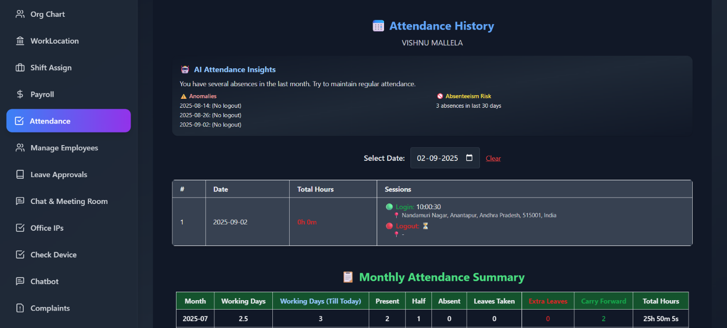

**Page Title:** *Attendance History*

**Features:**

* **Employee Details Displayed** – Name of the selected employee.
* **AI Attendance Insights:**
  + Shows anomalies (e.g., missing logout).
  + Highlights absenteeism risks (e.g., 3 absences in the last 30 days).
* **Date Selector** – Allows selecting attendance details for a specific date.
* **Daily Attendance Record Table:**
  + Date
  + Total Hours worked
  + Sessions (Login & Logout with timestamp and location)
* **Monthly Attendance Summary Table:**
  + Month
  + Working Days
  + Present / Half Days / Absent / Leaves Taken
  + Extra Leaves
  + Carry Forward Leaves
  + Total Hours

**Employee Management**

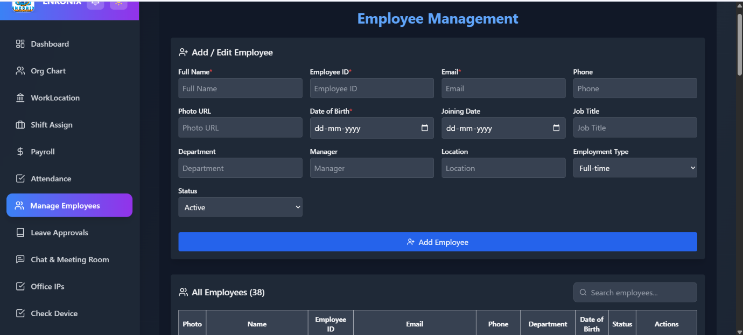

**Page Title:** *Employee Management*

**Features:**

* **Add / Edit Employee Form**
  + Full Name
  + Employee ID
  + Email
  + Phone
  + Photo URL
  + Date of Birth
  + Joining Date
  + Job Title
  + Department
  + Manager
  + Location
  + Employment Type (Full-time, Part-time, Contract)
  + Status (Active/Inactive)
  + **Button:** Add Employee
* **Employee List Table**
  + Photo
  + Name
  + Employee ID
  + Email
  + Phone
  + Department
  + Date of Birth
  + Status
  + Actions (Edit / Delete options)

**5. Key Highlights**

✔️ AI-powered Attendance Insights (detects anomalies, absenteeism risks).  
✔️ Centralized Employee Management.  
✔️ Easy-to-use interface with search & filters.  
✔️ Attendance tracking with login/logout sessions & geolocation.  
✔️ Monthly summary with leave balance and working hours.

**Leave Approvals Module**

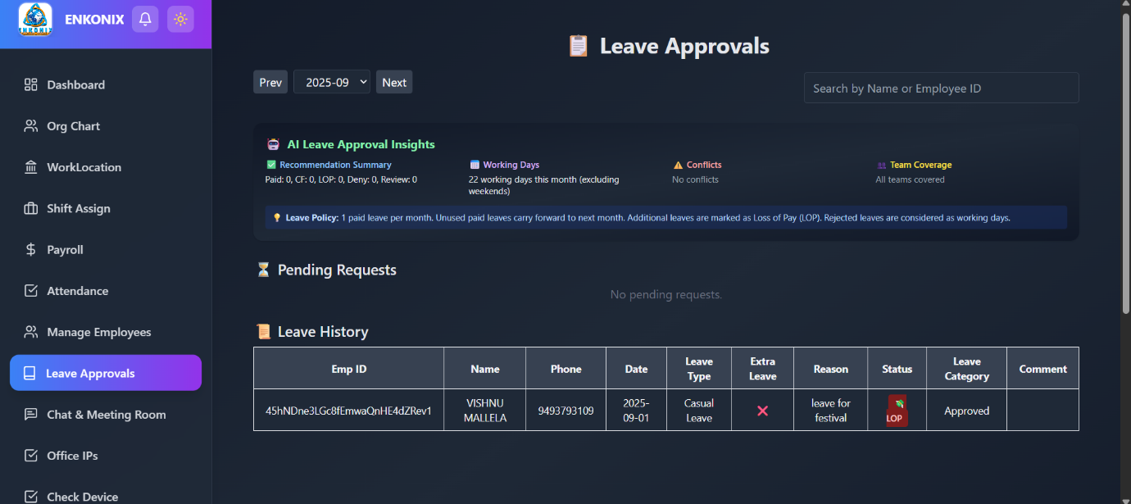

This module helps managers/admins approve or reject employee leave requests.

**Features**

* **AI Leave Approval Insights**
  + **Recommendation Summary:** Displays counts of Paid, Carry Forward (CF), Loss of Pay (LOP), Denied, and Review-required leaves.
  + **Working Days:** Shows total working days in the current month (excluding weekends).
  + **Conflicts:** Detects overlapping or conflicting leave requests.
  + **Team Coverage:** Ensures adequate team presence during leaves.
  + **Leave Policy Reminder:**
    - 1 paid leave per month.
    - Unused paid leave carries forward.
    - Extra leaves marked as **LOP (Loss of Pay)**.
    - Rejected leaves are treated as working days.
* **Pending Requests**
  + Displays all leave requests awaiting approval.
  + Search bar available (by Employee ID or Name).
* **Leave History**
  + Stores records of all processed leave requests with details:
    - **Emp ID, Name, Phone, Date, Leave Type, Extra Leave, Reason, Status, Leave Category, Comments.**
  + Example:
    - **Employee:** Vishnu Mallela
    - **Date:** 2025-09-01
    - **Type:** Casual Leave
    - **Reason:** Festival
    - **Status:** Approved
    - **Category:** LOP (since paid leave quota exceeded)

**Chat & Meeting Room Module**

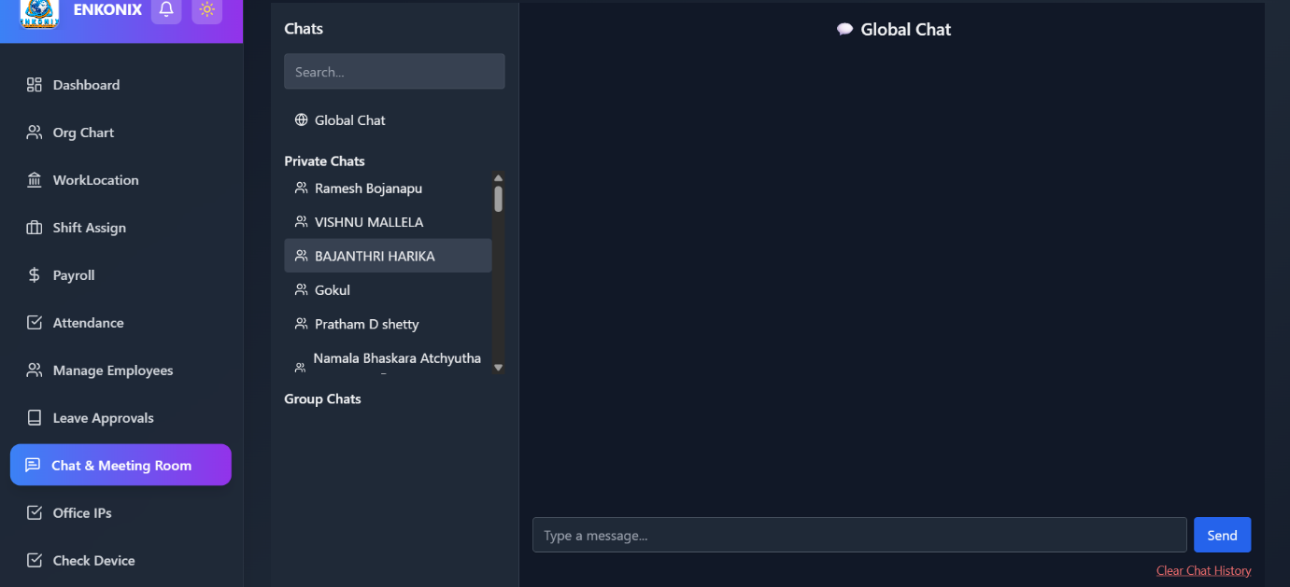

Enables communication and collaboration between employees.

**Features**

* **Global Chat**
  + Common discussion space for all employees.
* **Private Chats**
  + 1-to-1 messaging between employees.
  + Search bar to quickly find employees by name.
* **Group Chats**
  + Dedicated spaces for team/project-based communication.
* **Additional Options**
  + **Clear Chat History** for privacy and storage management.
  + Modern UI with left panel navigation (chats categorized as Global, Private, and Group).

**Office IPs Module**

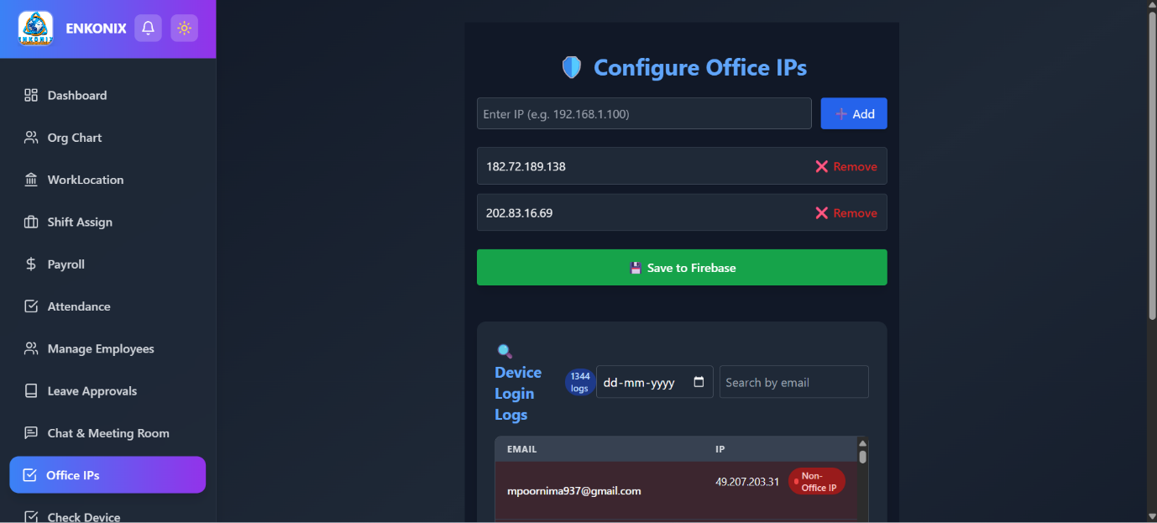

Ensures security by restricting system access to office-approved IPs.

**Features**

* **Add Office IPs**
  + Enter IP address manually (e.g., 192.168.1.100).
  + Click **+ Add** to whitelist.
* **Manage Existing IPs**
  + List of saved office IPs.
  + Option to **Remove** unauthorized IPs.
  + Save changes with **Save to Firebase** button.
* **Device Login Logs**
  + Tracks login activity of employees.
  + Filters available: **Date, Email Search**.
  + Log details include:
    - **Email** of employee
    - **IP Address**
    - **Status** → Office IP or Non-Office IP
* **Example Log:**
  + **User:** mpoornima937@gmail.com
  + **IP:** 49.207.203.31
  + **Status:** Non-Office IP

**Work Location & Device Monitoring**

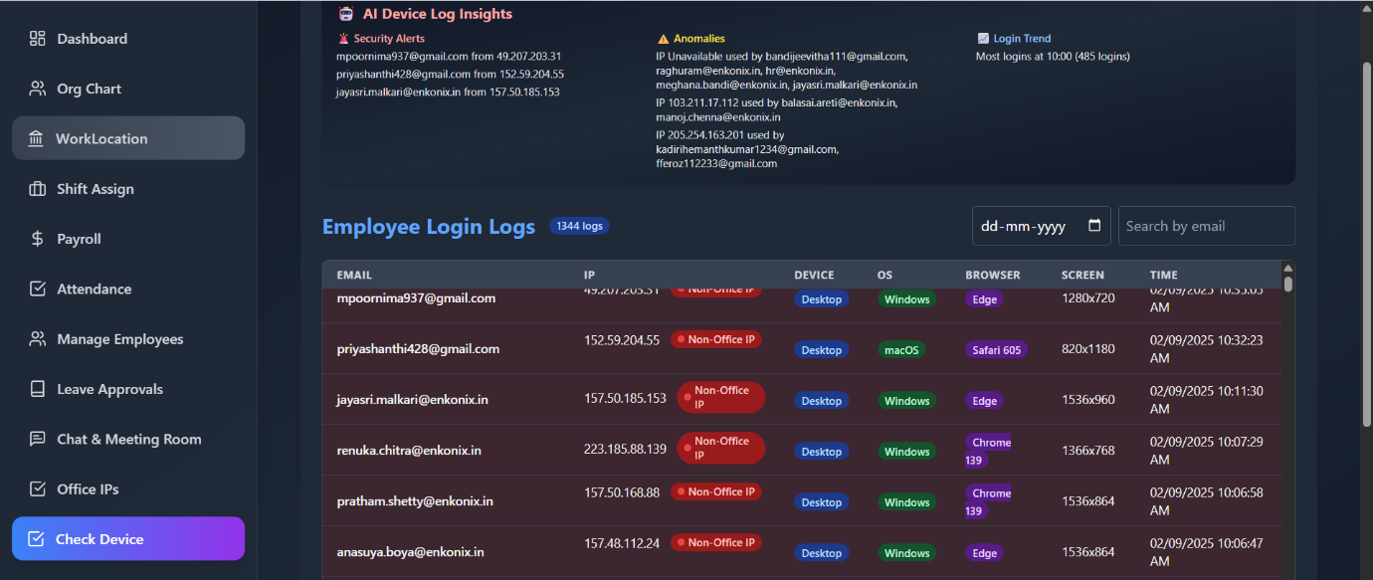

**🔹 Features:**

* **Employee Login Logs**:
  + Tracks employee login activity.
  + Columns: Email, IP, Device, OS, Browser, Screen Size, Timestamp.
  + Flags **Non-Office IPs** for security monitoring.
* **AI Device Log Insights**:
  + **Security Alerts**: Detects suspicious logins from unusual IPs.
  + **Anomalies**: Identifies shared or unavailable IP usage.
  + **Login Trends**: Shows peak login times.

**Chat & Meeting Room**

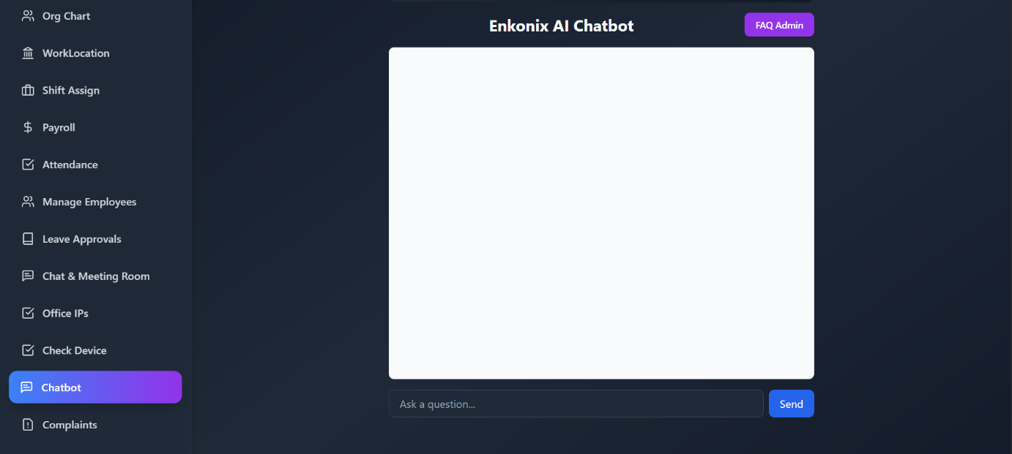

* Integrated **AI Chatbot** for HR and employee queries.
* Features:
  + FAQ Assistant.
  + Real-time query resolution.
  + Option to escalate issues to HR/Admin.

**Issue Management**

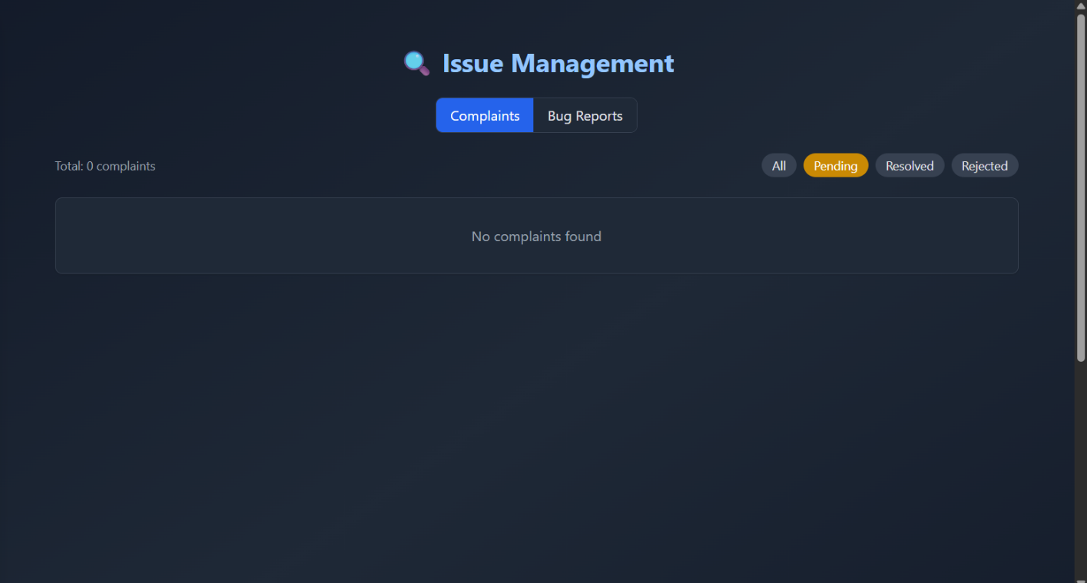

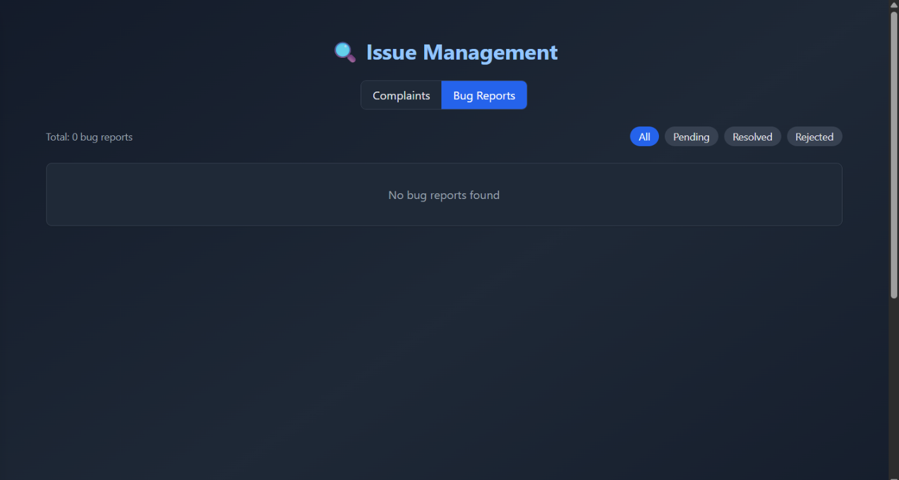

**🔹 Complaints**

* Tracks employee complaints.
* Statuses: **Pending, Resolved, Rejected**.
* Displays total complaints with filtering options.

**🔹 Bug Reports**

* Employees can report technical issues.
* Similar status tracking system as complaints.

**Voting & Polls**

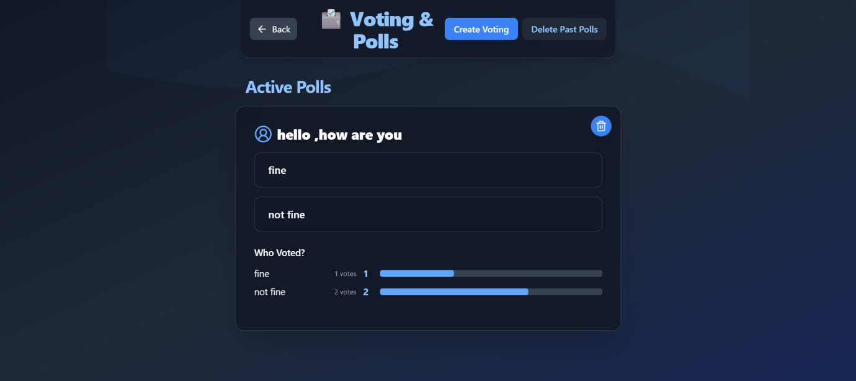

* Allows HR/admins to create polls.
* Employees can participate anonymously.
* Features:
  + Active polls with live results.
  + Vote count and percentage visualization.
  + Option to delete past polls.

**AI-Powered HR Analytics**

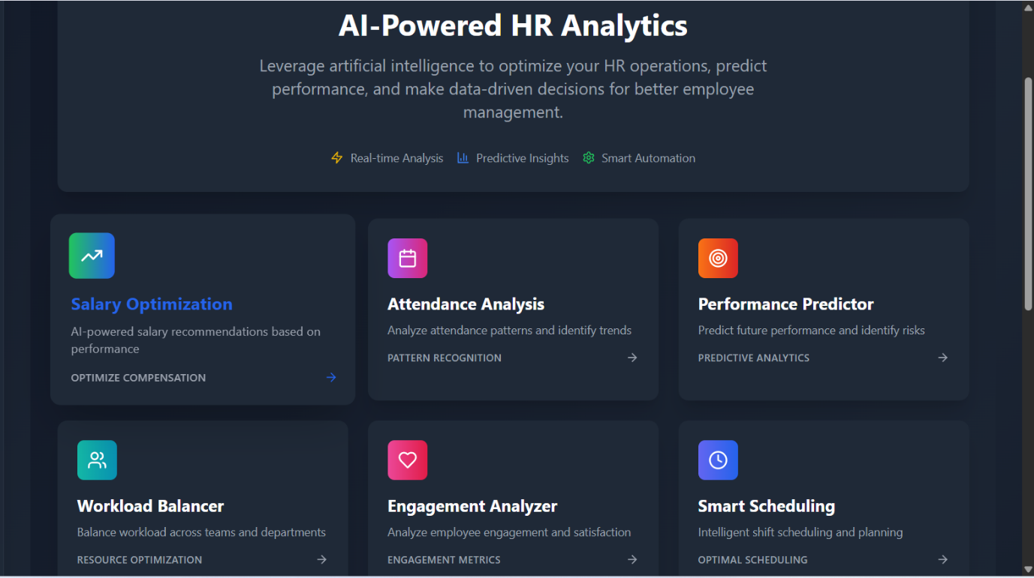

Provides actionable insights using AI:

* **Salary Optimization** – Suggests compensation adjustments.
* **Attendance Analysis** – Detects absenteeism & patterns.
* **Performance Predictor** – Predicts employee performance & risks.
* **Workload Balancer** – Ensures fair distribution of tasks.
* **Engagement Analyzer** – Measures employee satisfaction.
* **Smart Scheduling** – Automates shift planning.

**Settings**

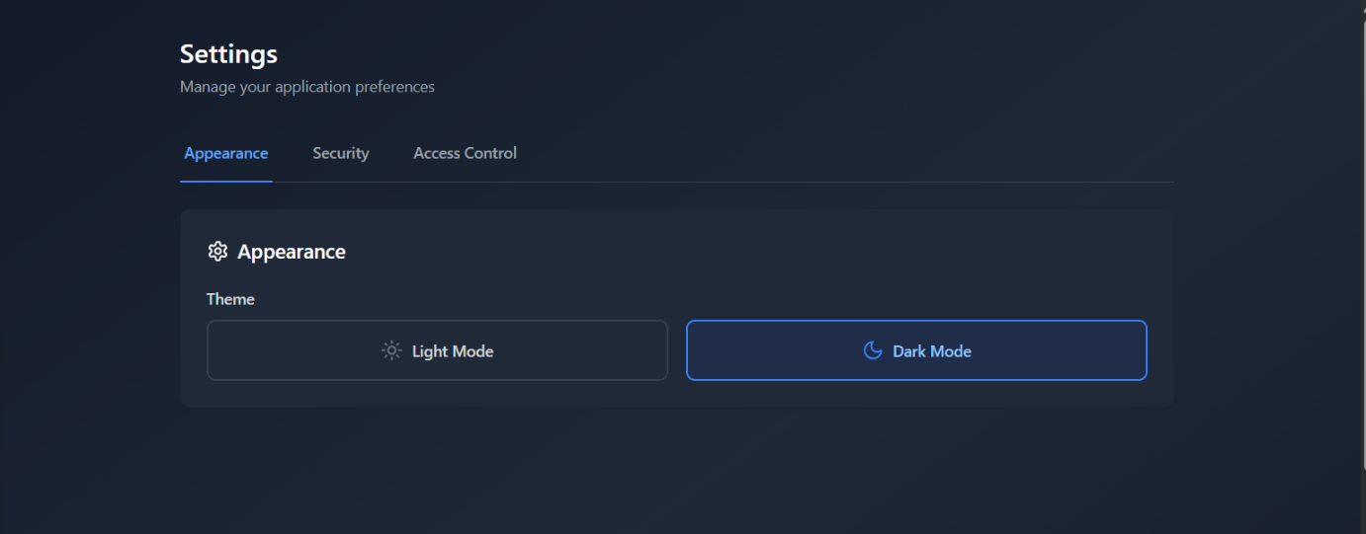

**🔹 Appearance**

* Toggle between **Light Mode** and **Dark Mode**.

**🔹 Security & Access Control**

* Manage user roles, permissions, and security preferences.
* Ensures only authorized employees access sensitive data.